**1.A.**

The **Big Bang nucleosynthesis (BBN)** also known as primordial nucleosynthesis predicts the production of nuclei other than those of the lightest isotope of Hydrogen during the Big Bang.

The composition of matter changes as the cosmos cools; new particles, such protons and neutrons, are created from previously existing ones, such as quarks. The universe was nearly **homogeneous** and strongly **radiation-dominated** between a few seconds and a few minutes of cosmic time, when the temperature had dropped below 10 billion Kelvin. At this time, the conditions were ideal for protons and neutrons to interact and form specific types of atomic nuclei. Big Bang Nucleosynthesis is the name of this stage.

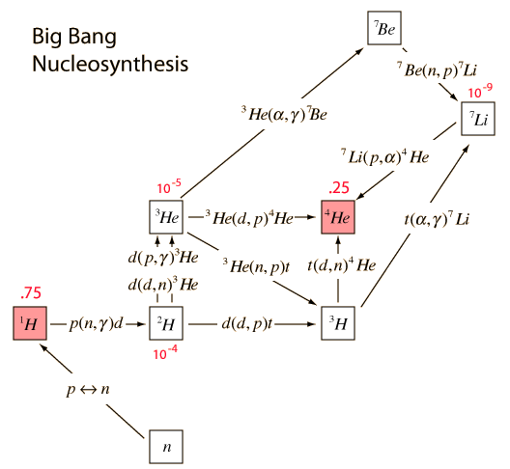

**Fig 1A**.1.illustration of hydrogen-helium abundance

According to the BBN, lithium, deuterium, and helium-3 are present in minuscule amounts (on the order of $10^-10)$, and there are very few heavier elements. **Hydrogen-1 makes up about 75% of the universe's mass, helium-4 makes up about 25%, and deuterium and helium-3 make up around 0.01% of all atoms.** The modern-day observed abundances in the universe are generally **consistent** with these abundance numbers and strongly favor for the Big Bang theory.

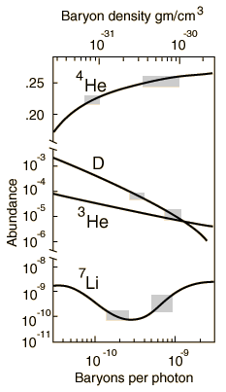

**Fig.1A.2**.modeling of production of helium and hydrogen-helium ratio predicted by BBT and BBN.

Also, the abundance of helium-4 as predicted by BBN provides an important test for the Big Bang theory as there is far more helium-4 in the universe than can be explained by **stellar nucleosynthesis**.

Additionally, the standard explanation now used for the **abundance of deuterium** is that the universe does not consist mostly of baryons, but that **non-baryonic matter** (also known as dark matter) makes up most of the mass of the universe. This explanation is also consistent with calculations that show that a universe made mostly of protons and neutrons would be far more clumpy than is observed which is in line with the prediction of BBN.

**B.**

In the history of the universe, it is believed that from 10−36 seconds after the conjectured Big Bang singularity to 10−32 seconds after the singularity the **universe expanded** by a factor of **1038** which is otherwise known as inflation. After this inflationary period, the universe continued to expand, but at a slower rate and it is only after this event that energy started converting into regular matter and radiation. Therefore, it is hard to predict any events in the first 10-32 seconds of the Big Bang as before this the **Planck era** and the **grand unified era** existed where the laws of physics were considerably different.

Einstein’s general relativity predicts the theoretical existence of **singularities**, but in practice, a singularity is where the laws of physics break down. Also, according to general relativity, nothing can travel faster than the speed of light but the current size of the universe could only be possible if it was expanding **faster than the speed of light** at some point in time as is predicted by inflation theory. General relativity also does not explain the vacuum energy at the quantum level.

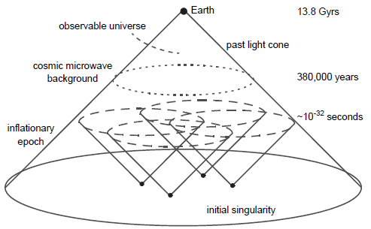

The **inflation theory** explains the expansion of the universe just after the big bang. It proposes a period of extremely rapid (exponential) expansion of the universe prior to the more gradual Big Bang expansion, during which time the energy density of the universe was dominated by a cosmological constant-type of **vacuum energy** that later decayed to produce the matter and radiation that fill the universe today. The inflation theory successfully explains the homogeneity of the universe, the flatness of the universe, and the non-existence of magnetic monopoles.

**2.A.**

In 1965, two researchers with Bell Telephone Laboratories (**Arno Penzias and Robert Wilson**) were given the assignment to **measure certain radio signals** for the idea of sending wireless signals via telephones. They used a radio antenna shaped like a horn. The problem was, no matter where they pointed this horn they kept hearing a static kind of **radio noise** coming from every direction. They soon realized the noise came uniformly from all over the sky and what they were hearing was not radio waves but a different form of **radiation- microwaves**, a heat signature left over from the big bang. They had discovered **the Cosmic Microwave Background (CMB) radiation**, a ghostly snapshot of the early universe.

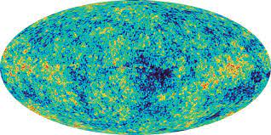

**Fig.2.A.**

The Cosmic Microwave Background Radiation (CMBR) is light that was emitted during the recombination epoch, when the universe's free electron density suddenly dropped due to the formation of **neutral hydrogen atoms**, making it possible for **light to travel over great distances** for the first time without being affected by Compton scattering. Since recombination, this light has been moving through the transparent cosmos and after **redshifting**, it has become the CMB radiation that we see.

The source of the photons in the first place is the **thermal radiation** of the particles in the universe during the time of recombination. This is caused by the **microscopic oscillations** of matter particles and should produce a continuous blackbody spectrum consistent with Planck's Law. Indeed, this is what we observe the CMB radiation to be like.

**B.**

Mean free path for will be inversely proportional to density of electron as well as the scattering cross section. As the photon is always moving with same velocity, the mean free path can be directly given by

$λ =\frac{1}{scattering cross section*electron density}$

Here, Thomson scattering cross section area = $6.65*{10}^{-29}m^{2}$

Electron density = $2*{10}^{8}m^{-3}$ ≈

Therefore, λ = 7.518796992481200 × ${10}^{19} m$

≈ $7.518*{10}^{19} m$

**C.**

The universe's abundance of matter can be gauged by the curvature of space, which is analogous to gravity. The light behaves like it is passing through a **lens** when it moves through a curved space because it bends as it does so. An object that is small appears larger in a universe that is (positively) curved. We can determine the curvature of the cosmos by knowing the actual size, such as a spot in the microwave background temperature caused by sound waves. We determine the eventual fate of the cosmos by measuring the curvature of the universe in the **size of spots** in the microwave background temperature maps.

Acoustic oscillations and diffusion damping serve as the primary determinants of the structure of the cosmic microwave background anisotropies. **Acoustic oscillations** are one of these two phenomena that give the microwave background its **characteristic peak structure**. The peaks generally match resonances where photons dissociate when a specific mode reaches its maximum amplitude. The peaks contain interesting physical signatures and the **angular scale of the first peak** determines the curvature of the universe.

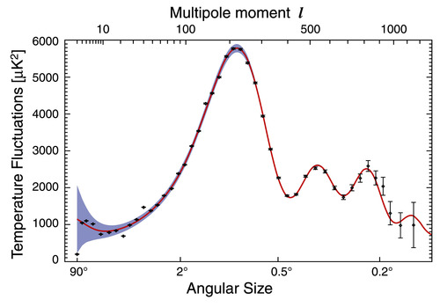

**Fig.2.C** .Acoustic oscillations ripple Data showing first peak

In 1959 the idea of using **space-borne gyroscopes** was proposed to detect the warping and twisting of spacetime around the earth. The curvature of space time can also be measured using time dilation in general relativity and many other tensors.

**D.**

Small variations in the temperature of the background radiation from point to point in the sky are called **anisotropies**. These anisotropies were first detected by the COBE (NASA's Cosmic Background Explorer) satellite in 1992.

Changes in temperature are due to changes in the density of the gas at the moment of recombination (higher densities equal higher temperatures). Since these photons are coming to us from the **last scattering epoch**, they represent fluctuations in density at that time. The slightly denser regions eventually grew increasingly denser, as gravity caused them to draw more and more matter from the surroundings. These primordial **fluctuations in the density** of matter in the early Universe led to the formation of the rich network of **cosmic structures** – stars, galaxies, galaxy clusters – that we observe today. It is thought that the fluctuations seen in the CMB are a result of the brief period of **inflation**.

The density fluctuations at recombination, as measured in the CMB, are too large and too low in amplitude to form **galaxy-sized clumps**. Instead, they are the seeds for galaxy cluster-sized clouds that later broke up into galaxies. The origin of these fluctuations are primordial **quantum fluctuations** from the very earliest moments that are echoed in the CMB at recombination.

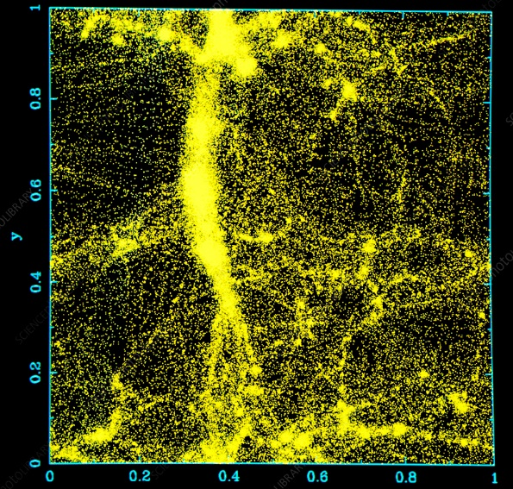

Fig. 2.D. Density fluctuations in early universe

To conclude, the CMB fluctuations are a **link** between the Big Bang and the large-scale structure of galaxies in the Universe, their distribution in terms of clusters of galaxies and filaments of galaxies that we observe around the Milky Way today.

**3.(A)**

Repulsive Pressure = Prep =

Attraction Pressure = Patt =

Force due to Surface Tension = $\frac{4T}{r}$

For equilibrium: Total pressure of attraction = Total pressure of repulsion

Patt+ PT = Prep

)

for universe to be neither contracting nor expanding, the equation must have at least one positive real root, but from [Descartes’ rule of sign](https://en.wikipedia.org/wiki/Descartes%27_rule_of_signs) this equation can only have 2 or 0 positive roots, also if the equation have 2 positive roots (equal or distinct) then the total number of real roots must be 3 (cubic equations have odd number of real roots). Now let’s assume our equation have 3 real roots (only feasible solution).

Here the local minima is at r = $√\frac{k1}{12T}$ which is positive, thus the equation must have one positive roots (assuming as all roots are real).

**Thus we can say that if the equation have 3 real roots then 2 of them will be positive otherwise no positive root will exist**

Now, for 3 real roots (all coefficients are real) [discriminant of cubic](https://en.wikipedia.org/wiki/Discriminant) must be greater than or equal to zero (both positive roots are equal):

$-4\left(4T\right)\left( {-k}_{1}^{3}\right)-27{\left(4T\right)}^{2}{\left(k2\right)}^{2}≥0$

${T\left(k1\right)}^{3}-27{\left(T\right)}^{2} {\left(k2\right)}^{2}≥0$**,**

This is the necessary and sufficient condition for where at least One value of least one value of Radius(r) exists where the universe is neither expanding nor contracting.

**3.(B)**

Following set of constants have cardinal number of possible radii, rest have no such radii (rest have cardinal number zero) where universe is neither expanding nor contracting.

|  |  |  |  |  |
| --- | --- | --- | --- | --- |
| k1 | k2 | T | number of possible radii |  |
| 989 | 80 | 238 | 2 |  |
| 540 | 135 | 259 | 2 |  |
| 590 | 479 | 1 | 2 |  |
| 692 | 268 | 55 | 2 |  |
| 507 | 21 | 638 | 2 |  |
| 505 | 93 | 163 | 2 |  |

Here the number of possible radii are the positive roots of the force balance equation.

$$\frac{k_{2}}{r^{4}}+ \frac{4T}{r}= \frac{k_{1}}{r^{3}}$$

The solution is obtained from the following python script

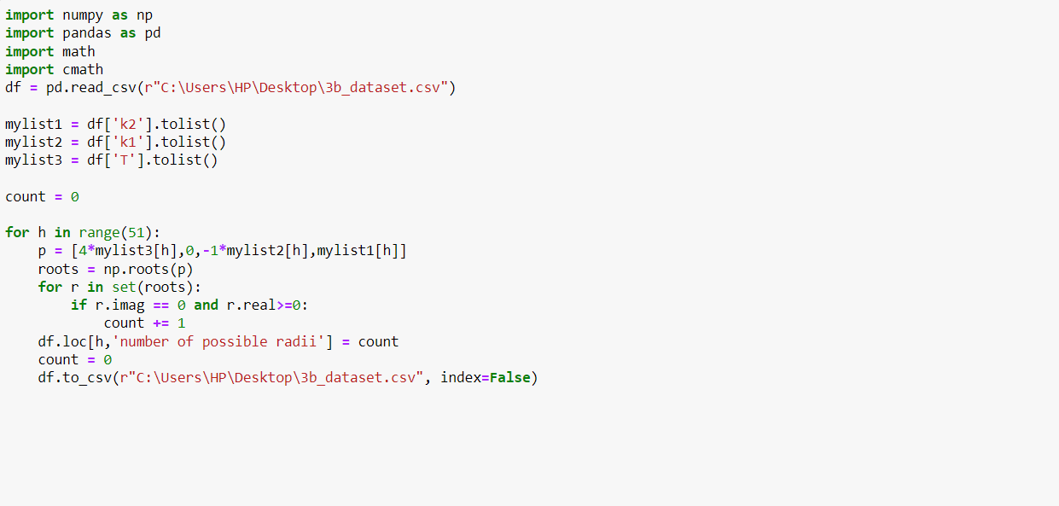Solution Dataset

<https://docs.google.com/spreadsheets/d/1HEowlKrUiX2U-04Vc0NW0YnVXVIKE253ID9AcRAQei8/edit?usp=sharing>

**3.(C).**

For given values of k1, k2, T and R all the systems are contracting.

Script used:

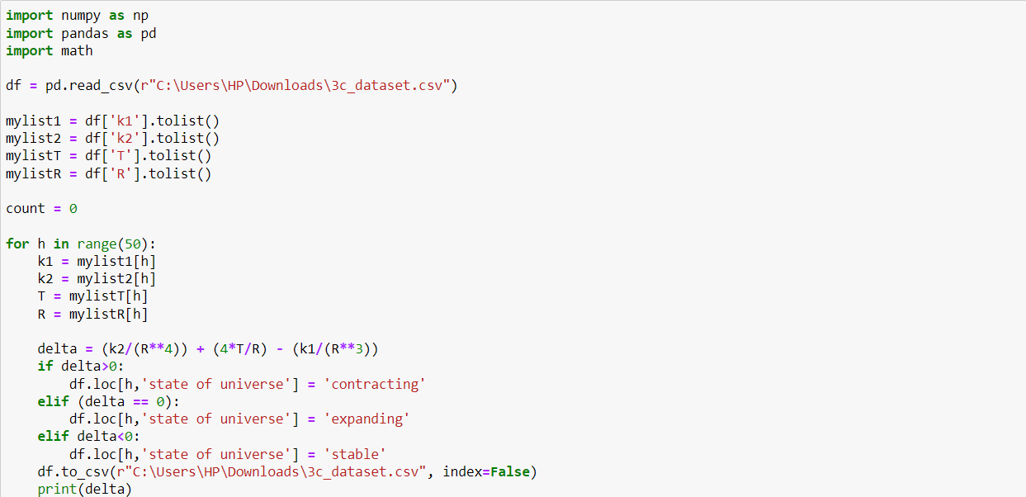solution dataset:

<https://drive.google.com/file/d/1_R7JL-sdjZ18NyJwX7xAk-XL6zEBl4oN/view?usp=sharing>

Following script is used to draw the graphs and mark the stable radii;

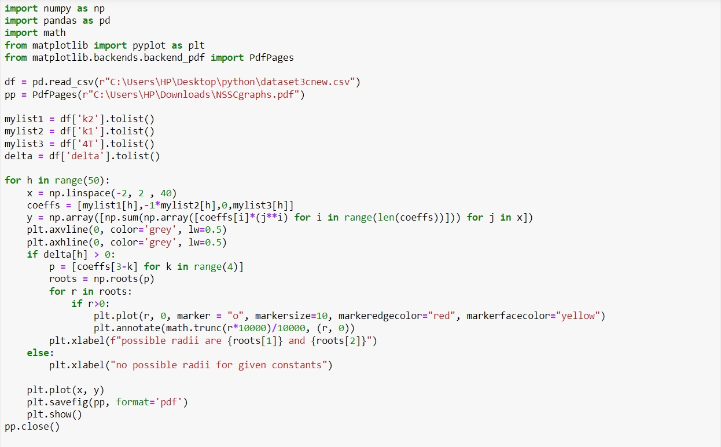

The generated graphs are:

<https://drive.google.com/file/d/1zLlckFueP9NIXANV-ID0I3tZodHFu33O/view?usp=sharing>

**4.A.**

Assuming that reionization did not occur but recombination happened:

Opacity – The universe would have been **transparent** but with **no visible light** because there were no light sources other than the gradually redshifting cosmic background radiation.

The abundance of large structures- The large-scale structures such as galaxies, nebulae, and quasars would have **continued to form** at roughly the same rate as in the present universe.

The overall composition of the universe- The universe would have remained **neutral** with no ionized plasma and would have remained in the state of cosmic dawn. However, the overall composition of the universe **wouldn’t be much affected** as the universe continued to expand forming galaxies and other large structures.

**B.**

For nearby objects in the universe, spectral absorption lines are very sharp, as only photons with energies just sufficient to cause an atomic transition can cause that transition. However, the distances between quasars and the telescopes which detect them are large, which means that the expansion of the universe causes light to undergo noticeable **redshifting**. This means that as light from the quasar travels through the IGM and is redshifted, wavelengths that had been below the **Lyman Alpha limit** are stretched, and will in effect begin to fill in the Lyman absorption band. This means that instead of showing sharp spectral absorption lines, a quasar's light that has travelled through a large, spread-out region of neutral hydrogen will show a **Gunn-Peterson trough**.

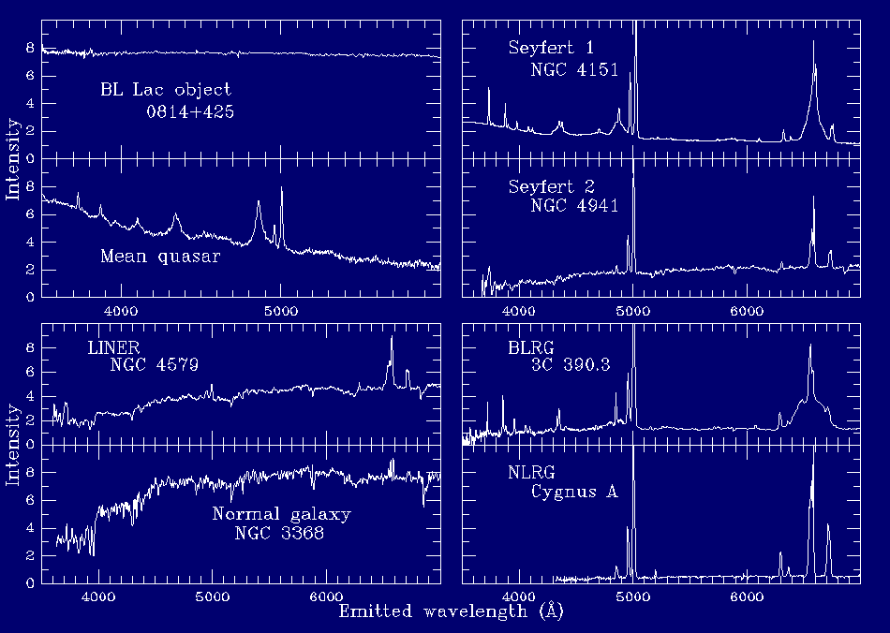

**Fig.4.B.** Spectrum Comparison – Active Galaxies and Quasars.

The redshifting for a particular quasar provides temporal (time) information about reionization. Since an object's redshift corresponds to the time at which it emitted the light, it is **possible to determine when reionization ended**. Quasars below a certain redshift (closer in space and time) do not show the Gunn-Peterson trough (though they may show the Lyman-alpha Forest), while quasars emitting light prior to reionization will feature a Gunn-Peterson trough.

**C.**

In 1944, Walter Baade categorized groups of stars within the Milky Way into **stellar populations**.

The first stars in the universe (very low metal content) were deemed population III, old stars (low metallicity) as population II, and recent stars (high metallicity) as population I.

Among these, **Population III stars** which will form supernovae are a possible mechanism for reionization. They provide a significant fraction of the **ionizing radiation** during the early universe and are thus an important component in understanding this rather turbulent period in the history of the universe. At first, these stars would simply form **pockets of ionized gas** around them which would then shrink back as the atoms recombine. Eventually, however, with the continued formation of stars and radiation emitted from active galactic nuclei, the universe has become fully ionized.

Observations of the galaxy UDFy-38135539 suggest that it may have played a role in this reionization process. The European Southern Observatory discovered a bright pocket of early population stars in the very bright galaxy Cosmos Redshift 7 from the reionization period around 800 million years after the Big Bang, at z = 6.60. These **observations** suggest that Population III stars are a better candidate in searching for reionization energy sources rather than Population I and II stars as these are relatively young stars and would not have been present around the time of reionization. These metal-rich and metal-poor stars came at a later stage in the universe's development.

**References:**

1. <https://en.wikipedia.org/wiki/Big_Bang_nucleosynthesis>
2. <https://astronomy.swin.edu.au/cosmos/b/big+bang#:~:text=From%20about%2010%2D33%20seconds,just%20after%20the%20Big%20Bang>.
3. <https://web.njit.edu/~gary/202/Lecture26.html>
4. <https://map.gsfc.nasa.gov/universe/bb_cosmo_infl.html#:~:text=The%20Inflation%20Theory%20proposes%20a,relatively%20gradually%20throughout%20its%20history>.
5. <https://www.quantamagazine.org/how-the-cosmic-dark-ages-snuffed-out-all-light-20200302/>
6. <https://en.wikipedia.org/wiki/Reionization>
7. <https://en.wikipedia.org/wiki/Cosmic_microwave_background>
8. <https://www.quora.com/What-is-the-cosmic-inflation-theory-How-does-cosmic-inflation-solve-the-horizon-problem>
9. <https://w.astro.berkeley.edu/~mwhite/darkmatter/bbn.html>